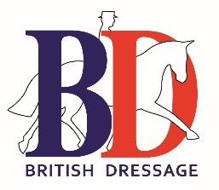

BD YOUTH AMBASSADOR

APPLICATION FORM

REGION: WALES

Name:
Address:
Contact Numbers:
Email:

Please detail your general experience & skills in relation to this role?

Please detail your equine specific experience & skills in relation to this role?
What are your thoughts on how British Dressage might develop relevant opportunities in the region?
In your opinion, detail why you feel that you would be suited to this role and your time availability to work within it?

Please return this form with a letter of application by e-mail to: wales@britishdressage.co.uk

