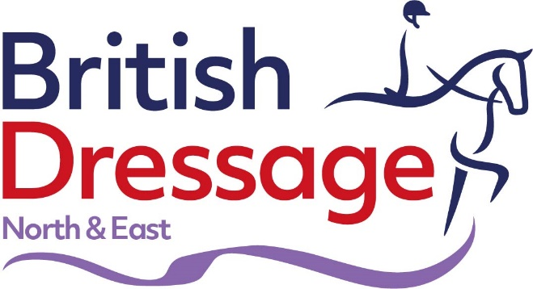
BD Youth Regional Rider Test League 2021
The league is intended as a friendly competition within the region and there will be an overall winner for each category and placings down to 10th. The prize giving will be at a presentation evening/ball in January 2022
Categories
- D Squad (to the end of the calendar year of 11th birthday)
- C Squad (to the end of the calendar year of 14th birthday)
- C+ Squad (to the end of the calendar year of 25th birthday)
- B Squad
- B+ Squad
- A Squad
How to enter
- Ride your squad BD Youth Rider test at ANY BD Official event (competition, flexi or training day and including the Northern Show) within the region that is able to facilitate an arena.
- If you are selected to represent your region at the BD Youth Inter Regionals these sheets can also be used.
- To qualify for the league you must have attended a Squad assessment/evaluation and ride a minimum of 4 tests between 1 April 2021 and 31st December 2021
- If you have been judged by a panel of judges for one single test (for example at the Inter Regionals), an average of the result will be taken.
- To continue, each time you ride a BD Youth Rider test you submit it by email to jo.byrne@britishdressage.co.uk as a scanned or photographed copy of your test sheet within 7 days of riding it
- All tests to be considered must be submitted by 2 January 2022
Who wins?
- The rider in each category achieving the most points between the 1 April 21 to 31st December 2021
- In the event of a tie, the four marks will be totalled and highest marks will count
- Only your best 4 scores will count
- Riders submitting fewer than four sheets will only be placed at the committees discretion
- Winners will be notified and advised of where the Award Ceremony will take place
Eligibility & Rules
- Riders must be eligible to ride at the level they wish to be ranked according to rule 172, Page 179 of the Handbook (Inter Regional Eligibility)
- Riders assessed will automatically be added to the tables. Please email Jo Byrne if you wish to opt out
- At least 2 of the tests to count must be marked by a different Youth Judge.
- Riders must have attended a North & East Region assessment day or later evaluated and riding in their age category within the BD Youth Criteria
- Riders must be a minimum of a Club Members on a BD Registered or Associate horse or pony or with DO agreement Club members on a riding school pony at centres holding shows or coaching.
Scoring & Points Allocation
BD Youth Rider Test League Points
FROM | TO | NO POINTS
55.00 | 59.99 | 1
60.00 | 64.99 | 2
65.00 | 65.99 | 3
66.00 | 66.99 | 4
67.00 | 67.99 | 5
68.00 | 68.99 | 6
69.00 | 69.99 | 7
70.00 | 70.99 | 8
71.00 | 71.99 | 9
72.00 | 72.99 | 10
73.00 | 73.99 | 11
74.00 | 74.99 | 12
75.00 | 75.99 | 13
76.00 | 76.99 | 14
77.00 | 77.99 | 15
78.00 | 78.99 | 16
79.00 | 79.99 | 17
80.00 | 80.99 | 18
81.00 | 81.99 | 19
82.00 | 82.99 | 20
83.00 | 83.99 | 21
84.00 | 84.99 | 22
85.00 | 85.99 | 23
86.00 | 86.99 | 24
87.00 | 87.99 | 25
88.00 | 88.99 | 26
89.00 | 89.99 | 27
90.00 | 94.99 | 28
95.00 | 97.99 | 29
98.00 | 100.00 | 30

Rider League Championships 2021
D Squad
C Squad

C+ Squad 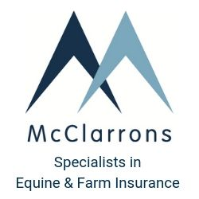
B Squad 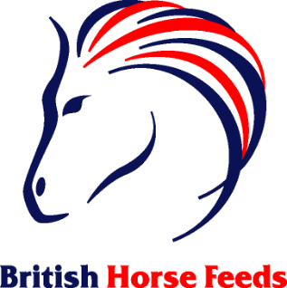
B+ Squad 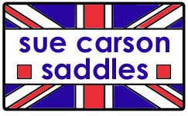

A Squad

Thank you!

