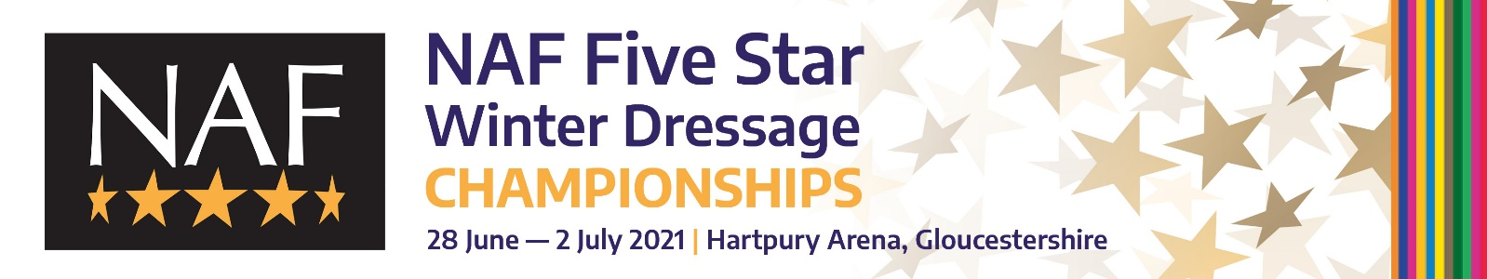

PRESS ACCREDITATION FORM

Please return this form email to joanna.bowns@britishdressage.co.uk or post:
Winnie Murphy, British Dressage, Building 2020, Copse Lane, Meriden Business Park, Meriden CV5 9RG by Friday 25 June 2021.

Name:

Address:

Telephone: Mobile:

Email:

Publication/Site/Programme:

I will be attending on:

Monday |  | Tuesday |  | Wednesday |  | Thursday |  | Friday

I have read and agree to be bound by the press accreditation terms & conditions and COVID policy.

SIGNATURE: DATE:

Please note that entries and results will be available online throughout the show on www.bdchampionships.com

NAF Five Star Winter Dressage Championships 2021
We look forward to welcoming you to Hartpury for five full days of competition 28 June – 2 July. We have a few items relating to press accreditation to make you aware of:
General
- The organisers reserve the right to decline any application which does not meet the accreditation criteria or remove the accreditation from any media found contravening these conditions.
- All press MUST be accredited by British Dressage and by attending agree to comply with the COVID protocols in place.
- Due to COVID restrictions, numbers will be limited due to space in order to maintain social distancing.
- Only recognised editorial staff and photographers will be considered for accreditation and editorial evidence thereof may be requested. Press accreditation must be completed prior to the show.
- Freelancers - All requests from freelancers should be submitted in writing and signed by the editor confirming commissioned coverage of the event.
- Websites - Only editorial staff from relevant websites may apply for accreditation. Websites using information and news linking from other sources will not be accredited.
- Broadcast- Accreditation for reporters should be submitted using the accreditation form. All requests should be in accordance with standard broadcasting guidelines and subsequent guidelines of the organisers.
- Photographers- In signing and submitting this accreditation photographers agree to these conditions.
- Parking this year is extremely tight due to it being term time – spaces will be on a first come, first served basis and no car passes will be issued.
- Press arrive via the main show entrance and on showing their accreditation letter will be shown to the parking. Make your way to the Press Office in the main Hartpury Arena where you MUST sign in and collect their ticket/ badge.
- All relevant UK legislation must be observed, including Health and Safety legislation.
- Any media in breach of these conditions will have their accreditation withdrawn, be asked to leave the grounds and will not be accredited in future.
Filming/ Radio
- Broadcast crews must be escorted at all times.
- No filming can take place without the permission of British Dressage.
- No film crews must enter the collecting rings.
Press Access Areas
- Press may access all public areas. Please maintain social distancing when occupying any seating. Masks must be worn indoors at all times except while working in the press room.
- Press may also access both Arenas’ collecting rings but please listen to any instruction by the Arena Stewards for your safety.
- The stables are not open to members of the press.
Press/ Rider Interviews
- Riders will be held following each prize giving at the presentation area on the BD tradestand for brief interviews.
- Should you require any further time or other riders/officials/judges please ask the Press Office staff to arrange this for you.

Photographers
- Photographers are asked to dress tidily and in keeping with a Championship occasion. NO DENIM is permitted in the arenas at any time.
- Photographers are welcome to position themselves outside the perimeter of the three arenas.
- It is understood and accepted as a condition of attending the show that, with the exception of the Official Photographer or a direct agreement with the show organiser, press or freelance photographers at the show are not permitted to market their photographs or images of the show as available for sale to competitors or their connections at the show and / or after the show including via websites and / or Facebook. Press or freelance may only sell images from the show to clients that have commissioned their services prior to the show.
Contact Details
All press enquiries to: Winnie Murphy or Joanna Bowns, British Dressage winnie.murphy@britishdressage.co.uk/ 07809 826842 joanna.bowns@britishdressage.co.uk/02476 698839

