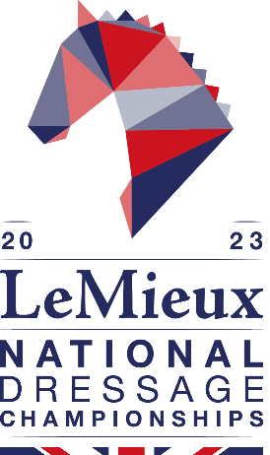

LeMieux National Dressage Championships
14 – 17 September 2023
Somerford Park, Cheshire

PRESS ACCREDITATION FORM

Please return this form via email to joanna.bowns@britishdressage.co.uk or post to: Joanna Bowns, British Dressage, Meriden Business Park, Copse Drive, Meriden, West Midlands CV5 9RG, by Friday 18 August 2023.

Name:

Address:

Telephone: Mobile:

Email:

Publication/Site/Programme:

I will be attending on:

Thursday Friday Saturday Sunday

Please tick if you require a car pass

Please note that results will be available online throughout the show on www.britishdressage.co.uk/national-dressage-championships

SIGNATURE: DATE:

LeMieux National Dressage Championships 2023
We look forward to welcoming you to Somerford Park for four full days of competition 14 – 17 September. We have a few items relating to press accreditation to make you aware of:
General
- The organisers reserve the right to decline any application which does not meet the accreditation criteria or remove the accreditation from any media found contravening these conditions.
- All press MUST be accredited by British Dressage
- Only recognised editorial staff and photographers will be considered for accreditation and editorial evidence thereof may be requested. Press accreditation must be completed prior to the show.
- Freelancers - All requests from freelancers should be submitted in writing and signed by the editor confirming commissioned coverage of the event.
- Websites - Only editorial staff from relevant websites may apply for accreditation. Websites using information and news linking from other sources will not be accredited.
- Broadcast - Accreditation for reporters should be submitted using the accreditation form. All requests should be in accordance with standard broadcasting guidelines and subsequent guidelines of the organisers.
- Photographers - In signing and submitting this accreditation, photographers agree to these conditions.
Filming/ Radio
- Broadcast crews must be escorted at all times.
- No filming can take place without the permission of British Dressage.
- No film crews must enter the collecting rings.
Press Access Areas
- Press may access all free public areas.
- Press may also access the collecting ring but please listen to any instruction by the Arena Stewards for your safety.

Press/ Rider Interviews
- Riders will be held following each prize giving at the exit of the arena for brief interviews.
- Should you require any further time or other riders/officials/judges please ask the Press Office staff to arrange this for you.

Photographers
- Photographers are asked to dress tidily and in keeping with a Championship occasion. NO DENIM is permitted in the main arena at any time.
- Photographers are welcome to position themselves outside the perimeter of the arenas.
- It is understood and accepted as a condition of attending the show that, with the exception of the Official Photographer or a direct agreement with the show organiser, press or freelance photographers at the show are not permitted to market their photographs or images of the show as available for sale to competitors or their connections at the show and / or after the show including via websites and/or any social media. Press or freelance may only sell images from the show to clients that have commissioned their services prior to the show.
Contact Details
All press enquiries to: Joanna Bowns, British Dressage
02476 698839
joanna.bowns@britishdressage.co.uk

